Final Project: Cricinfo
Ishrat Fatima 22F-3616
Sabahat Jahangir 22F-3617

Code:
1.Header File:
#include<iostream>
#include<string>
using namespace std;
class Team;
class player
{
string Name;
string ICC_ranking;
float Average;
int Shirt_No, runs, wickets, Matches_played;

public:
//default constructer
player();

//Setters
void setName(string Name);
void setICCrank(string ICC_ranking);
void setaverage(float Average);
void setshirt_no(int shirt_no);
void setruns(int runs);
void setwickets(int wickets);
void setmatchesplayed(int Matches_played);

//Getters
string getname();
string geticcrank();
float getaverage();
int getshirtno();
int getruns();
int getwickets();
int getmatchesplayed();

//other functions
int addPlayer();
int removePlayer(player **Player, int Team_num);

void searchPlayer(player **Player, Team *team);

void updatePlayer(player **Player);
void save_to_file(player **Player, int team_num, int size);
void read_from_file(player **Player,int size);
void ShowPlayer(player **Player, int team_num, int player_num);

};
class Team :public player
{
string team_name, Team_Captain, Team_Coach;
int No_of_Players, team_rank;
int Total_matches_won, Total_matches_lost;

string Admin_Username;
string Admin_Password;

public:

//default constructer
Team();

//Login function
void login();

//setters
void set_no_ofplayer(int no_of_players);
void set_team_name(string team_name);
void set_total_matchesW(int Total_matches_won);
void set_total_matchesL(int Total_matches_lost);
void setTeam_rank(int team_rank);
void set_team_captain(string Team_Captain);
void set_team_coach(string Team_Coach);
void set_admin_username(string Admin_username);
void set_password(string Admin_password);

//getters
int getNo_of_player();
string getTeam_name();
int getTotal_matchesW();
int getTotal_matchesL();
int getTeam_rank();
string getTeam_captain();
string getTeam_coach();
string getusername();
string getpassword();

//Displaying teams
void displayTeams(Team *team);
void displayTeam(player **Player, int num, int size);

//displaying team ICC ranking
void displayteamrank(Team *team);

//updating capatains and coaches
void updateCaptain(Team *team);
void updateCoach(Team *team);

//saving data to file
void save_to_file(Team *team);

//retrieving data from file
void read_from_file(Team *team);

};
static int matchIndex = 0;

class Match :public Team
{
string team1, team2, date, venue, match_type, tournament_name;
string Commentators[2], Umpires[2];
string Match_status;

public:
//default constructer
Match();

//setters
void setTeam1(string team1);
void setTeam2(string team2);
void setDate(string date);
void setVenue(string venue);
void setMatch_Type(string match_type);
void setTournament_name(string tournament_name);
void setMatch_status(string Match_status);
//Getters
string getTeam1();
string getTeam2();
string getDate();
string getVenue();
string getMatch_Type();
string getTournament_name();
string getMatch_status();
string getCommentators();
string getUmpires();

void ConductMatch(Match matchObj[], int size);
void scheduleMatch(Match matchObj[], int size);
void matchMenu(Match matchObj[], int size);

//Displaying Matches
int displayMatches(Match match_obj[], int size);
void displayRecentMatches(Match match_obj[], int size);
void displayUpcomingMatches(Match match_obj[], int size);

void save_to_file(Match match_obj[], int size);
void read_from_file(Match match_obj[], int size);

};

Source File:
#include<iostream>
#include<string>
#include<fstream>
#include<iomanip>
#include"Header.h"
using namespace std;
//**********************************************************************************************
//**************************************" PLAYER "*****************************************************
//**********************************************************************************************
//default constructer
player::player()
{
this->Average = 0;
this->ICC_ranking = "null";
this->Matches_played = 0;
this->Name = "null";
this->runs = 0;
this->Shirt_No = 0;
this->wickets = 0;

}
//********************************************************************************************
int player::addPlayer()
{
cout << "\nEnter Name : ";
cin >> Name;
cout << "Enter ICC_ranking : ";
cin >> ICC_ranking;
cout << "Enter Matches_played : ";
cin >> Matches_played;
cout << "Enter Runs : ";
cin >> runs;
cout << "Enter Average : ";
cin >> Average;
cout << "Enter Shirt_No : ";
cin >> Shirt_No;
cout << "Enter wickets : ";
cin >> wickets;

return 1;
}
//********************************************************************************************
//remove player
int player::removePlayer(player **Player, int Team_num)
{
string name;
int index;

cout << "Enter the Name of the player which you want to remove : ";
cin >> name;

for (int j = 0; j < 11; j++)
{
if (name == Player[Team_num - 1][j].Name)
{
//storing the index of the palyer which we want to remove
index = j;
break;
}
}

if (!(index == 10))
{
//deleting the player
for (int j = index; j < 11; j++)
{
for (int k = j + 1; k < 11; k++)
{
Player[Team_num - 1][j] = Player[Team_num - 1][k];
}
}
index = 11;
}

else if (index == 10)
{
for (int j = index; j < 11; j++)
{
Player[Team_num - 1][j].Name = " ";
Player[Team_num - 1][j].Average = 0;
Player[Team_num - 1][j].ICC_ranking = " ";
Player[Team_num - 1][j].Matches_played = 0;
Player[Team_num - 1][j].runs = 0;
Player[Team_num - 1][j].Shirt_No = 0;
Player[Team_num - 1][j].wickets = 0;
}

}

return 1;
}
//***********************************************************************************************
//search player
void player::searchPlayer(player **Player, Team *team)
{
string name;
int indexteam, indexplayer;
string reading;

ifstream read;
read.open("player.txt", ios::in);
bool flag = false;
cout << "Enter the Name of the player which you want to Search : ";
cin >> name;
read_from_file(Player, 11);
//searching player
for (int i = 0; i < 6; i++)
{
for (int j = 0; j < 11; j++)
{

if (!(Player[i][j].Name != name))
{
indexteam = i;
indexplayer = j;
flag = true;
break;

}
else if (Player[i][j].Name != name)
{

indexteam = 100;
indexplayer = 100;

}
}
if (flag == true)
{
break;
}
}
if (indexteam == 100 && indexplayer == 100)
{
cout << "\nPlayer not Found." << endl;
}
else
{
cout << "\nPlayer Found.\n" << endl;
cout << team[indexteam].getTeam_name() << " 's Team Player :- \n" << endl;

cout << " Player's Name\t" << "ICC_ranking\t" << " Average \t" << " Matches_played \t" << " Runs\t\t" << "Shirt_No \t" << " Wickets " << endl;
ShowPlayer(Player, indexteam, indexplayer);
cout << endl;
}

}
//********************************************************************************************

void player::ShowPlayer(player **Player, int team_num, int player_num)
{
cout << setw(17) << Player[team_num][player_num].getname() << "\t";
cout << Player[team_num][player_num].geticcrank() << " \t\t";
cout << Player[team_num][player_num].getaverage() << " \t\t ";
cout << Player[team_num][player_num].getmatchesplayed() << "\t\t\t ";
cout << Player[team_num][player_num].getruns() << "\t\t";
cout << Player[team_num][player_num].getshirtno() << "\t\t ";
cout << Player[team_num][player_num].getwickets() << endl;

}
//********************************************************************************************
//update player
void player::updatePlayer(player **Player)
{
string name;
// int index;
int returnvalue = 0;
int team_num;

cout << "Enter the Name of the player which you want to Update : ";
cin >> name;

//searching player
for (int i = 0; i < 6; i++)
{
for (int j = 0; j < 11; j++)
{
if (name == Player[i][j].Name)
{
returnvalue = addPlayer();
team_num = i;
}
}

}
cout << "\n Player has been SuccessFully Updated. :)" << endl;

}
//********************************************************************************************
//save to file function
void player::save_to_file(player **Player, int team_num, int size)
{
ofstream write;
write.open("player.txt", ios::app);

for (int j = 0; j < size; j++)
{
write << Player[team_num][j].Name << "\t";
write << Player[team_num][j].ICC_ranking << " \t\t";
write << Player[team_num][j].Average << " \t\t ";
write << Player[team_num][j].Matches_played << "\t\t\t ";
write << Player[team_num][j].runs << "\t\t";
write << Player[team_num][j].Shirt_No << "\t\t ";
write << Player[team_num][j].wickets << endl;
}

write.close();
}
//********************************************************************************************
//read from file
void player::read_from_file(player **Player, int size)
{
ifstream read;
read.open("player.txt");

if (read.is_open())
{
for (int i = 0; i < 6; i++)
{
for (int j = 0; j < size; j++)
{
read >> Player[i][j].Name;
read >> Player[i][j].ICC_ranking;
read >> Player[i][j].Average;
read >> Player[i][j].Matches_played;
read >> Player[i][j].runs;
read >> Player[i][j].Shirt_No;
read >> Player[i][j].wickets;
}
}
}

read.close();
}
//********************************************************************************************
//Setters
void player::setName(string Name)
{
this->Name = Name;
}
void player::setICCrank(string ICC_ranking)
{
this->ICC_ranking = ICC_ranking;
}
void player::setaverage(float Average)
{
this->Average = Average;

}
void player::setshirt_no(int Shirt_no)
{
this->Shirt_No = Shirt_No;
}
void player::setwickets(int wickets)
{
this->wickets = wickets;
}
void player::setmatchesplayed(int Matches_played)
{
this->Matches_played = Matches_played;
}
//********************************************************************************************
//Getters
string player::getname()
{
return Name;
}
string player::geticcrank()
{
return ICC_ranking;
}
float player::getaverage()
{
return Average;
}
int player::getshirtno()
{
return Shirt_No;
}
int player::getwickets()
{
return wickets;
}
void player::setruns(int runs)
{
this->runs = runs;
}
int player::getruns()
{
return runs;
}
int player::getmatchesplayed()
{
return Matches_played;
}

//*********************************************************************************************
//**************************************" TEAM "*****************************************************
//*********************************************************************************************
//default constructer
Team::Team() :player()
{
this->Total_matches_won = 0;
this->Total_matches_lost = 0;
this->No_of_Players = 0;
this->Team_Captain = "null";
this->Team_Coach = "null";
this->Admin_Username = "null";
this->Admin_Password = "null";
}
//********************************************************************************************
void Team::login()
{
cout << "Enter UserName : ";
cin >> Admin_Username;
cout << "Enter passward:\t";
cin >> Admin_Password;

while (Admin_Username != "admin" || Admin_Password != "admin")
{
cout << "\t\t\tWrong ! Enter username again:\t";
cin >> Admin_Username;
cout << "\t\t\tEnter passward again:\t";
cin >> Admin_Password;
}

cout << "\nSuccessFully Logged In." << endl;

}

//********************************************************************************************
void Team::save_to_file(Team *team)
{
ofstream file;

file.open("Team.txt", ios::in);
for (int i = 0; i < 6; i++)
{
file << team[i].getTeam_name() << " ";
file << team[i].getTeam_coach() << " ";
file << team[i].getTeam_captain() << " ";
file << team[i].getTeam_rank() << " ";
file << team[i].getNo_of_player() << " ";
file << team[i].getTotal_matchesW() << " ";
file << team[i].getTotal_matchesL() << " ";
file << endl;
}

file.close();
}
void Team::read_from_file(Team *team)
{
ifstream read;

read.open("Team.txt", ios::out);
for (int i = 0; i < 6; i++)
{
read >> team[i].team_name;
read >> team[i].Team_Coach;
read >> team[i].Team_Captain;
read >> team[i].team_rank;
read >> team[i].No_of_Players;
read >> team[i].Total_matches_won;
read >> team[i].Total_matches_lost;
}

read.close();
}
//********************************************************************************************
void Team::updateCaptain(Team *team)
{
string CaptainName;

cout << "Enter the New Captain's name: ";
cin >> CaptainName;

set_team_captain(CaptainName);
save_to_file(team);

}
//********************************************************************************************
void Team::updateCoach(Team *team)
{
string CoachName;

cout << "Enter the New Coach's Name: ";
cin >> CoachName;

set_team_coach(CoachName);
save_to_file(team);
}
//********************************************************************************************
void Team::displayTeams(Team *team)
{
team->read_from_file(team);

cout << "\n******************* TEAMS *******************" << endl;
for (int i = 0; i < 6; i++)
{
cout << i + 1 << ". " << team[i].getTeam_name() << endl;
}

}
//********************************************************************************************
void Team::displayteamrank(Team *team)
{
team->read_from_file(team);

cout << "\n TEAMS\t\t\tICC Ranking\n" << endl;
for (int i = 0; i < 6; i++)
{
cout << setw(10) << team[i].getTeam_name() << " \t\t\t " << team[i].getTeam_rank() << endl;
}
cout << endl;

}
//********************************************************************************************
void Team::displayTeam(player **Player, int num, int size)
{

cout << "\n\n**********************************************************************************\n\n";
cout << "\n*******************************************" << team_name << "*******************************************" << endl;
cout << "\n\n**********************************************************************************\n\n";
cout << " Player's Name\t" << "ICC_ranking\t" << " Average \t" << " Matches_played \t" << " Runs\t\t" << "Shirt_No \t" << " Wickets " << endl;

Player[num]->read_from_file(Player, size);

for (int j = 0; j < 11; j++)
{
ShowPlayer(Player, num, j);
}

}
//********************************************************************************************
//setters
void Team::set_no_ofplayer(int no_of_players)
{
this->No_of_Players = no_of_players;
}
void Team::set_team_name(string team_name)
{
this->team_name = team_name;
}
void Team::setTeam_rank(int Team_rank)
{
this->team_rank = team_rank;
}
void Team::set_total_matchesW(int Total_matches_won)
{
this->Total_matches_won;
}
void Team::set_total_matchesL(int Total_matches_lost)
{
this->Total_matches_lost = Total_matches_lost;

}
void Team::set_team_coach(string Team_coach)
{
this->Team_Coach = Team_coach;
}
void Team::set_team_captain(string Team_Captain)
{
this->Team_Captain = Team_Captain;
}
void Team::set_admin_username(string Admin_username)
{
this->Admin_Username = Admin_Username;
}
void Team::set_password(string Admin_password)
{
this->Admin_Password = Admin_Password;
}

//********************************************************************************************
//Getters

string Team::getTeam_name()
{
return team_name;
}
int Team::getNo_of_player()
{
return No_of_Players;
}
int Team::getTotal_matchesW()
{
return Total_matches_won;
}
int Team::getTotal_matchesL()
{
return Total_matches_lost;
}
int Team::getTeam_rank()
{
return team_rank;
}
string Team::getTeam_captain()
{
return Team_Captain;
}

string Team::getTeam_coach()
{
return Team_Coach;
}
string Team::getusername()
{
return Admin_Username;
}
string Team::getpassword()
{
return Admin_Password;
}

//*******************************************************************************************
//**************************************" MATCH "*****************************************************
//*******************************************************************************************
//default constructer
Match::Match()
{
this->team1 = "null";
this->team2 = "null";
this->Match_status = "null";
this->tournament_name = "null";
this->Umpires[0] = "null";
this->venue = "null";
this->Commentators[0] = "null";
this->date = "null";
this->match_type = "null";

}
//********************************************************************************************
void Match::matchMenu(Match matchObj[], int size)
{

int option = 0;

cout << "1. Conduct Already Shedule Match" << endl;
cout << "2. Shedule New Match" << endl << endl;

cout << "Enter Option : ";
cin >> option;

if (option == 0)
{
ConductMatch(matchObj, 6);
}
else if (option == 1)
{
scheduleMatch(matchObj, 6);
}

}
//********************************************************************************************
void Match::ConductMatch(Match matchObj[], int size)
{

int option = 0;
read_from_file(matchObj, 8);

for (int i = 0; i < size; i++)
{
cout << i + 1 << " - " << matchObj[i].getTeam1() << " vs " << matchObj[i].getTeam2() << endl;
}

cout << "\nEnter Option : ";
cin >> option;

cout << "Match Conducting " << option << endl;
save_to_file(matchObj, 8);

}

//********************************************************************************************
void Match::displayRecentMatches(Match match_obj[], int size)
{
ifstream read;
string date, match_detail, timing;

read.open("PreviousMatches.txt", ios::in);

if (read.is_open())
{
cout << " \tDate\t\t" << "\tPrevious Match Details 2022 " << "\t\tVenue\n" << endl;
for (int i = 0; i < size; i++)
{
read >> match_obj[i].date;
read >> match_obj[i].team1;
read >> match_obj[i].team2;
read >> match_obj[i].venue;
}
for (int i = 0; i < size; i++)
{
cout << " " << setw(16) << match_obj[i].date << "\t\t";
cout << setw(10) << match_obj[i].team1 << " VS ";
cout << setw(10) << match_obj[i].team2 << "\t\t";
cout << match_obj[i].venue;
cout << endl;
}
cout << endl;
}
}
//********************************************************************************************
void Match::displayUpcomingMatches(Match match_obj[], int size)
{
ifstream read;

read.open("UpcomingSchedule.txt", ios::in);
if (read.is_open())
{
cout << " \tDate\t\t" << "\tUpcoming Match Details 2023 " << "\t\tVenue\n" << endl;

for (int i = 0; i < size; i++)
{
read >> match_obj[i].date;
read >> match_obj[i].team1;
read >> match_obj[i].team2;
read >> match_obj[i].venue;
}
for (int i = 0; i < size; i++)
{
cout << " " << setw(16) << match_obj[i].date << "\t\t";
cout << setw(10) << match_obj[i].team1 << " VS ";
cout << setw(10) << match_obj[i].team2 << "\t\t";
cout << match_obj[i].venue;
cout << endl;
}
cout << endl;
}
}
//********************************************************************************************
int Match::displayMatches(Match match_obj[], int size)
{

int choice;

cout << "For Previous Matches => Press 1" << endl;
cout << "For Upcoming Matches => Press 2" << endl;
cout << "For Both Matches => Press 3" << endl;
cout << "\n Enter your choice : ";
cin >> choice;
switch (choice)
{
case 1:
displayUpcomingMatches(match_obj, size);
break;

case 2:
displayRecentMatches(match_obj, size);
break;

case 3:
displayUpcomingMatches(match_obj, size);
displayRecentMatches(match_obj, size);
break;

default:
cout << "Oops! Wrong Input." << endl;
break;
}

return 1;
}
//********************************************************************************************
void Match::scheduleMatch(Match matchObj[], int size)
{

cout << "Enter Team 1 Name : ";
cin >> matchObj[matchIndex].team1;

cout << "Enter Team 2 Name : ";
cin >> matchObj[matchIndex].team2;

cout << "Enter Match Date : ";
cin >> matchObj[matchIndex].date;

cout << "Enter Match Type : ";
cin >> matchObj[matchIndex].match_type;

cout << "Enter Tournament Name : ";
cin >> matchObj[matchIndex].tournament_name;

matchIndex++;

}
//**************************************************************************************

void Match::save_to_file(Match match_obj[], int size)
{
ofstream write;
write.open("Matches.txt", ios::out);

write << getTournament_name() << endl;
write << getMatch_Type() << endl;

for (int i = 0; i < size; i++)
{
write << match_obj[i].getDate() << " ";
write << match_obj[i].getTeam1() << " ";
write << match_obj[i].getTeam2() << " ";
write << match_obj[i].getVenue() << " ";
for (int i = 0; i < 2; i++)
{
write << match_obj[i].Commentators[i] << " ";
}
for (int i = 0; i < 2; i++)
{
write << match_obj[i].Umpires[i] << " ";
}
write << endl;

}
}
void Match::read_from_file(Match match_obj[], int size)
{

ifstream read;
read.open("Matches.txt", ios::in);

read >> match_obj->tournament_name;
read >> match_obj->match_type;

for (int i = 0; i < size; i++)
{
read >> match_obj[i].date;
read >> match_obj[i].team1;
read >> match_obj[i].team2;
read >> match_obj[i].venue;
for (int i = 0; i < 2; i++)
{
read >> match_obj[i].Commentators[i];
}
for (int i = 0; i < 2; i++)
{
read >> match_obj[i].Umpires[i];
}

}

}
//**************************************************************************************
//setters
void Match::setTeam1(string team1)
{
this->team1 = team1;
}

void Match::setTeam2(string team2)
{
this->team2 = team2;
}
void Match::setDate(string date)
{
this->date = date;
}
void Match::setVenue(string venue)
{
this->venue = venue;
}
void Match::setMatch_Type(string match_type)
{
this->match_type = match_type;
}
void Match::setTournament_name(string tournament_name)
{
this->tournament_name = tournament_name;
}
void Match::setMatch_status(string Match_status)
{
this->Match_status = Match_status;
}
//**************************************************************************************
//Getters
string Match::getTeam1()
{
return team1;
}
string Match::getTeam2()
{
return team2;
}
string Match::getDate()
{
return date;
}
string Match::getVenue()
{
return venue;
}
string Match::getMatch_Type()
{
return match_type;
}
string Match::getTournament_name()
{
return tournament_name;
}
string Match::getMatch_status()
{
return Match_status;
}
string Match::getCommentators()
{
return Commentators[0];
}
string Match::getUmpires()
{

return Umpires[0];
}
Main:
#include<Windows.h>
#include<iomanip>
#include<iostream>
#include<string>
#include"Header.h"
using namespace std;
void displaystart();
int displaymenu();
void News();
int main()
{
int input_from_function;
int team_num;
int size = 12;
//player double Pointer
player **player_obj;
player_obj = new player*[6];
for (int i = 0; i < 6; i++)
{
player_obj[i] = new player[size];
}

//match pointer
Match *matchObj;
matchObj = new Match[8];

Team *team;
team = new Team[6];

system("Color 0A");

displaystart();

//team->login();

input_from_function = displaymenu();
team->read_from_file(team);

system("cls");

switch (input_from_function)
{
case 1:

team->displayTeams(team);

break;

case 2:
team->displayteamrank(team);
break;

case 3:
team->displayTeams(team);
cout << "For All, Press 7" << endl;
cout << "Which Team You want to be Displayed : ";
cin >> team_num;

if (team_num == 7)
{
for (int i = 0; i < 6; i++)
{
team[i].displayTeam(player_obj, i,11);
}
}
else
{
team->displayTeam(player_obj, team_num,11);
}

break;

case 4:
cout << "\n\tCoachs List : \n" << endl;
for (int i = 0; i < 6; i++)
{
cout << setw(10) << team[i].getTeam_name() << "'s Coach : " << team[i].getTeam_coach() << endl;
}
cout << endl;
break;

case 5:
cout << "\n\tCaptains List : \n" << endl;
for (int i = 0; i < 6; i++)
{
cout << setw(10) << team[i].getTeam_name() << "'s Captain : " << team[i].getTeam_captain() << endl;
}
cout << endl;
break;
case 6:

team->displayTeams(team);

cout << "\nWhich team's Coach you want to update : \n";
cin >> team_num;
cout << team[team_num - 1].getTeam_name() << "'s Coach : " << team[team_num - 1].getTeam_coach() << endl;

team[team_num - 1].updateCoach(team);

cout << "\nAfter Updating :\n" << endl;

cout << team[team_num - 1].getTeam_name() << "'s Coach : " << team[team_num - 1].getTeam_coach() << endl;

break;
case 7:

team->displayTeams(team);

cout << "\nWhich team's Captain you want to update : \n";
cin >> team_num;

cout << team[team_num - 1].getTeam_name() << "'s Captain : " << team[team_num - 1].getTeam_captain() << endl;

team[team_num - 1].updateCaptain(team);

cout << "\nAfter Updating :\n" << endl;

cout << team[team_num - 1].getTeam_name() << "'s Captain : " << team[team_num - 1].getTeam_captain() << endl;

break;

case 8:

team->searchPlayer(player_obj, team);

break;

case 9:
team->displayTeams(team);

cout << "In Which Team you want to Add player : ";
cin >> team_num;

player_obj[team_num-1]->read_from_file(player_obj, 11);

for (int i = 0; i < 6; i++)
{

if (team_num-1 == i)
{
player_obj[i]->addPlayer();
player_obj[i]->save_to_file(player_obj, team_num - 1, 12);
cout << "Player is Added SuccesFully." << endl;
}
else
{
player_obj[i]->save_to_file(player_obj,i, 11);
}
}

break;

case 10:

team->displayTeams(team);

cout << "\nWhich team's Player you want to remove : \n";
cin >> team_num;

player_obj[team_num - 1]->read_from_file(player_obj, 11);

team[team_num-1].removePlayer(player_obj, team_num);

cout << "\nPlayer has been removed SuccesFully." << endl;

break;

case 11:

team->displayTeams(team);

cout << "Which team you want to update player : ";
cin >> team_num;

team->updatePlayer(player_obj);

break;

case 12:
matchObj->displayMatches(matchObj,8);
// matchObj->displayRecentMatches(matchObj,6);
break;

case 13:
matchObj->ConductMatch(matchObj, 6);

break;

case 14:

matchObj->displayRecentMatches(matchObj, 6);

break;

case 15:

News();

break;

default:
cout << "Wrong! Input." << endl;
break;

}

system("pause");
}
void displaystart()
{
cout << "\n\n*****************************************************************************" << endl;
cout << "*****************************************************************************" << endl;

cout << "\n WelCome to CricBuzz Application" << endl;

cout << "\n*****************************************************************************" << endl;
cout << "*****************************************************************************" << endl;
cout << "\n\n\t\t Login \n\n" << endl;

}
int displaymenu()
{
system("cls");

int input;

cout << "\n1.Team List. " << endl;
cout << "2.Team Ranking. " << endl;
cout << "3.Team Players. " << endl;
cout << "4.Team Coachs. " << endl;
cout << "5.Team Captains. " << endl;
cout << "6.Update Team's Coach. " << endl;
cout << "7.Update Team's Captain. " << endl;
cout << "8.Search Player. " << endl;
cout << "9.Add a Player to Team. " << endl;
cout << "10.Remove Player from Team. " << endl;
cout << "11.Update PLayer of team. " << endl;
cout << "12.Scheduled Match. " << endl;
cout << "13.Conduct a Match. " << endl;
cout << "14.Recent Matches. " << endl;
cout << "15.News. " << endl;
cout << "\n\n Press any Key to EXIST. " << endl;

cout << "\n Enter the Option : \t";
cin >> input;

return input;

}
void News()
{
cout << "Latest and Breaking News." << endl;
cout << "\n\nPakistan Cricket Board (PCB) Chairman Ramiz Raja is likely to be replaced." << endl;
Sleep(60);
cout << "\nPakistan writes history on opening day of third England Test " << endl;
cout << "\nPakistan vs England, 3rd Test, Day 1 Highlights: England Trail Pakistan By 297 Runs At Stumps.\n " << endl;
cout << "\n" << endl;
}
Displaying Teams:
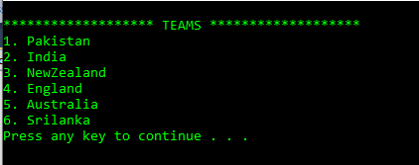
Displaying Teams Ranking:
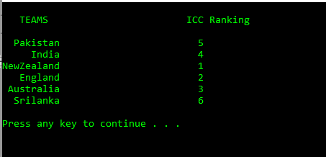
Displaying Teams:
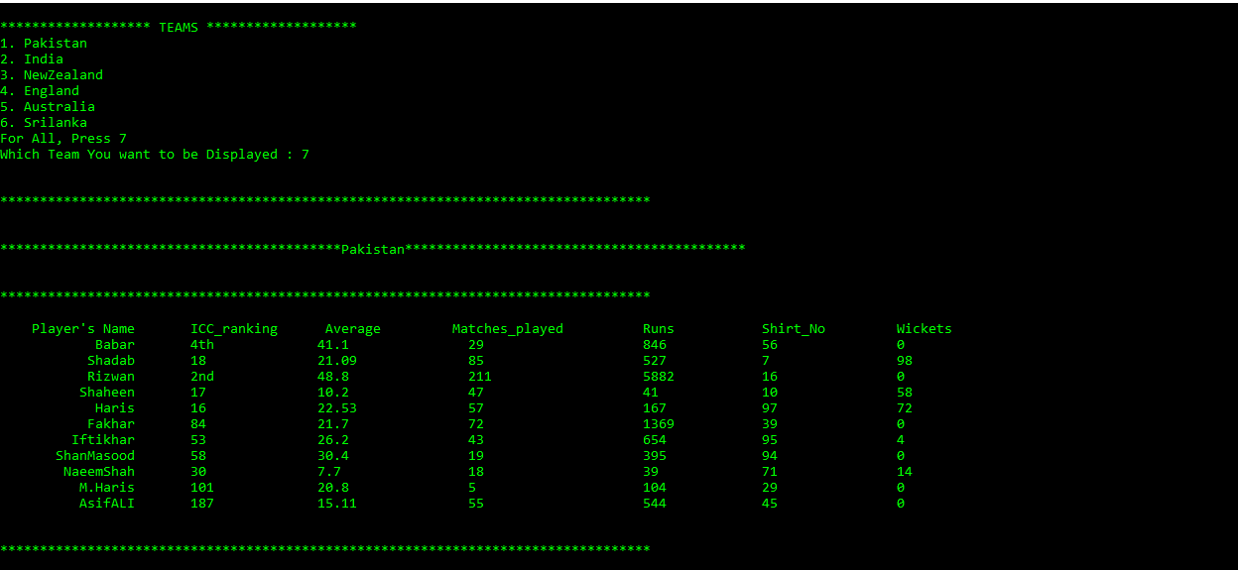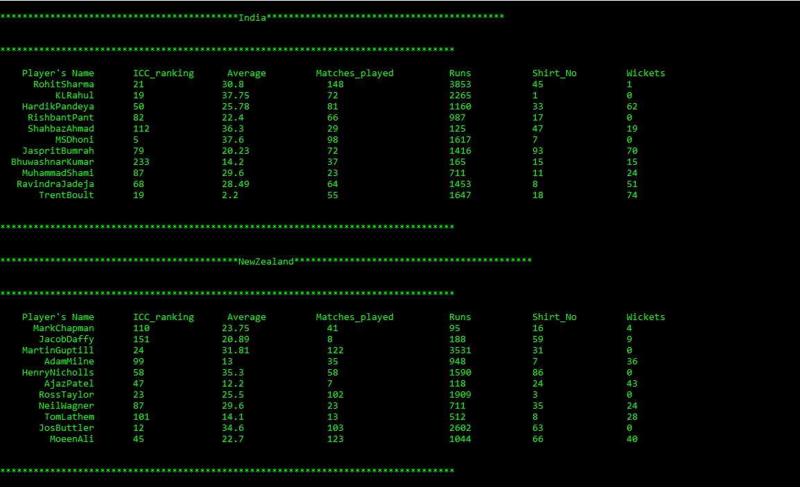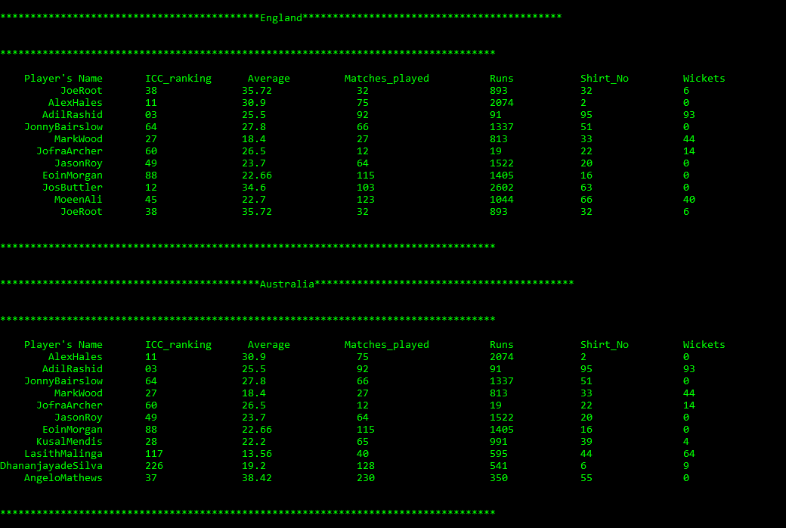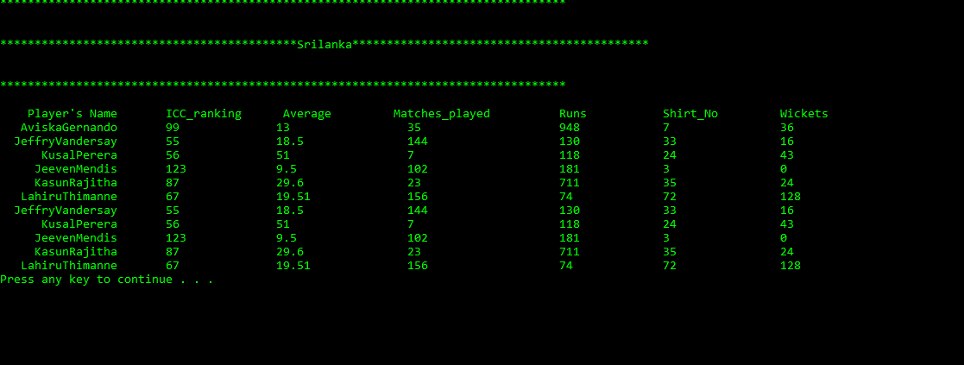
Displaying Coaches:
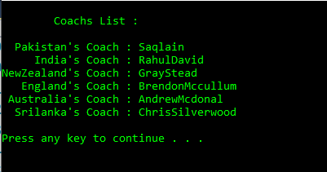

Displaying Captains:
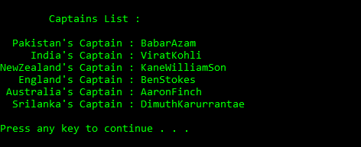
Updating Coach:
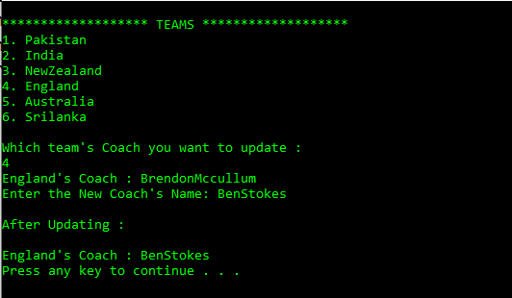
Updating Captain:
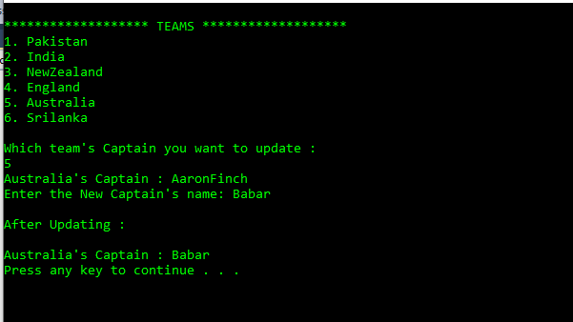Searching Player:
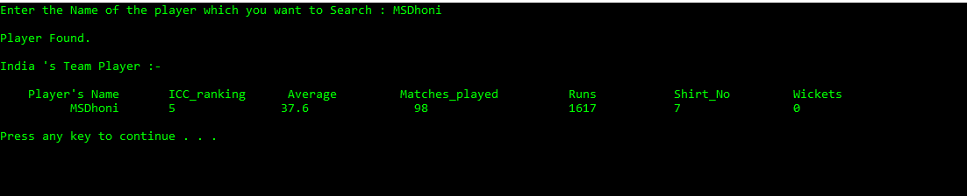Adding the Player:
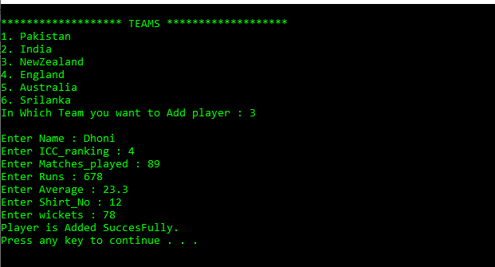
Removing Player:
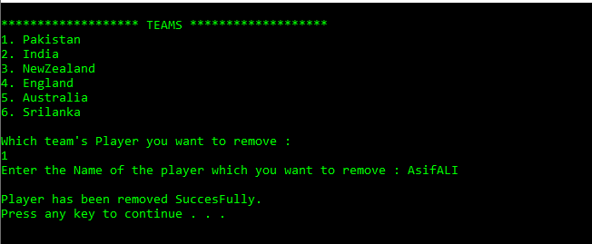
Updating Player:
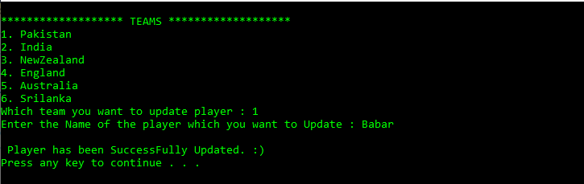
Displaying Recent Matches
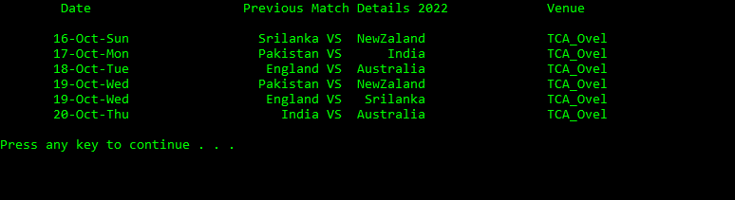

Displaying Recent and Upcoming Matches:
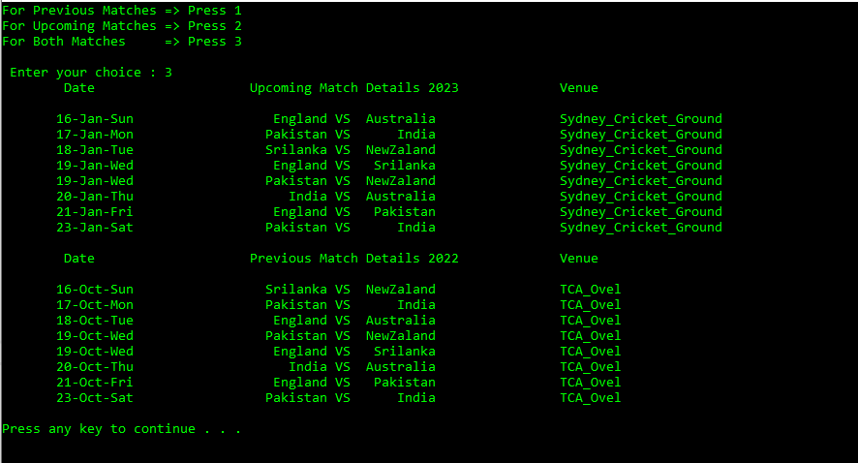
Conducting Matches
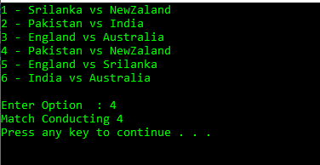
News:
